UG UTAG Member Dashboard Manual
Purpose: A concise guide for UG UTAG members who were imported into the system explains first-time sign-in, secure password setup, and common tasks you will perform (announcements, events, chat, and document sharing).
Prerequisites
- You have been imported into the system as a UG UTAG member.
- Your login is your staff email.
- Your temporary password is your Staff ID (issued by HR or the department).
- On first login you will be required to change that temporary password to a secure personal password.

1) Website — open the public site
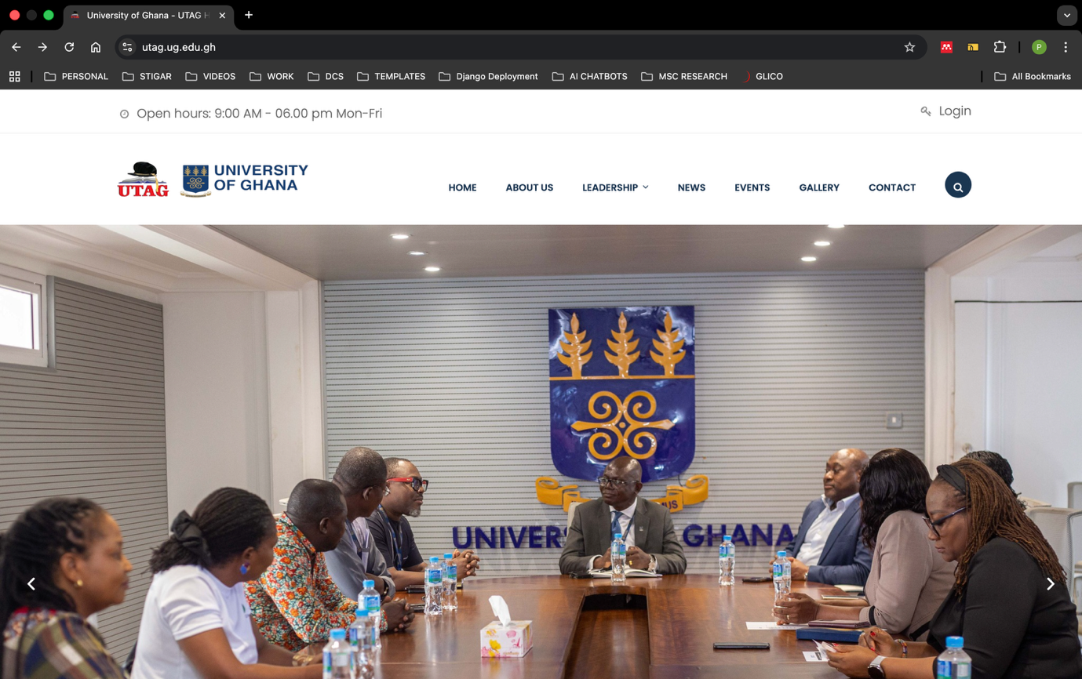
From the public University website https://utag.ug.edu.gh, locate and click the Login link in the top-right corner of the page. This takes you to the site login page.

2) Login — enter credentials
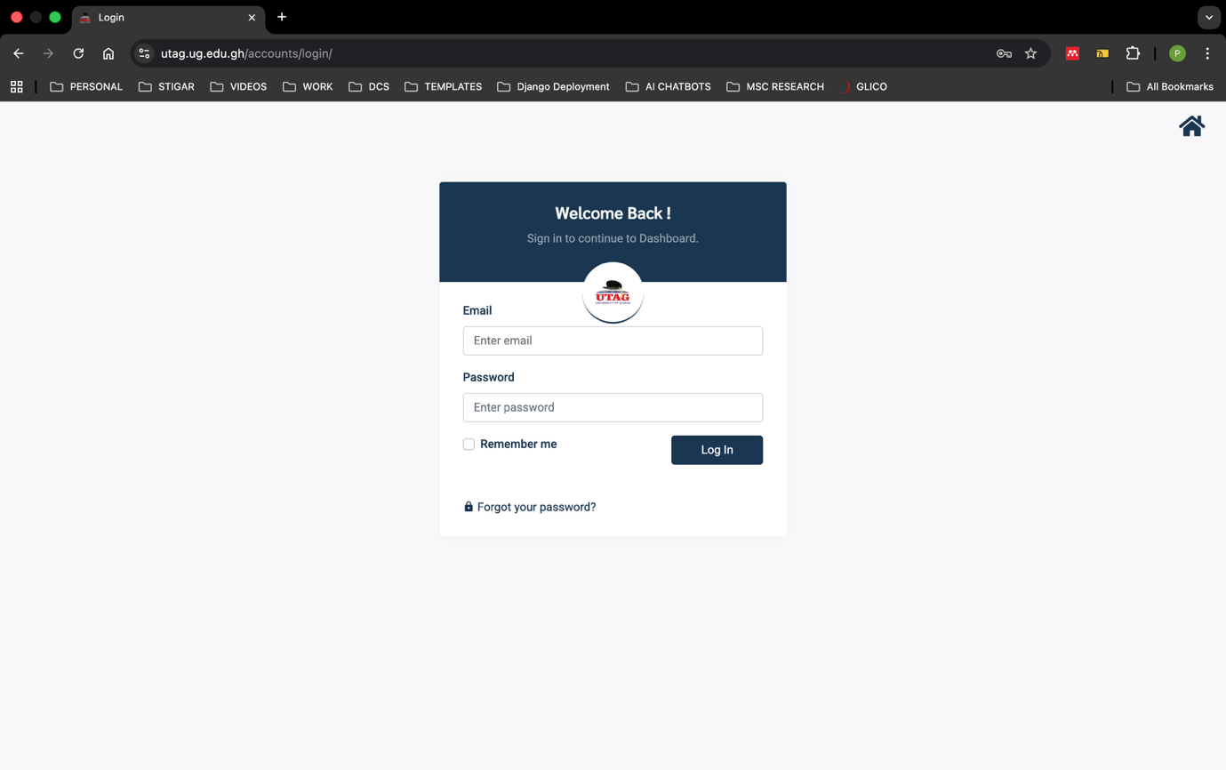
- On the login page complete the form:
  - Email: enter your staff email.
  - Password: enter your Staff ID (temporary password).
  - Optionally check Remember me on trusted devices.
  - Click the Log in.
What to expect immediately:
- If credentials are valid, you will be redirected to a password-change screen.

3) First-time password change
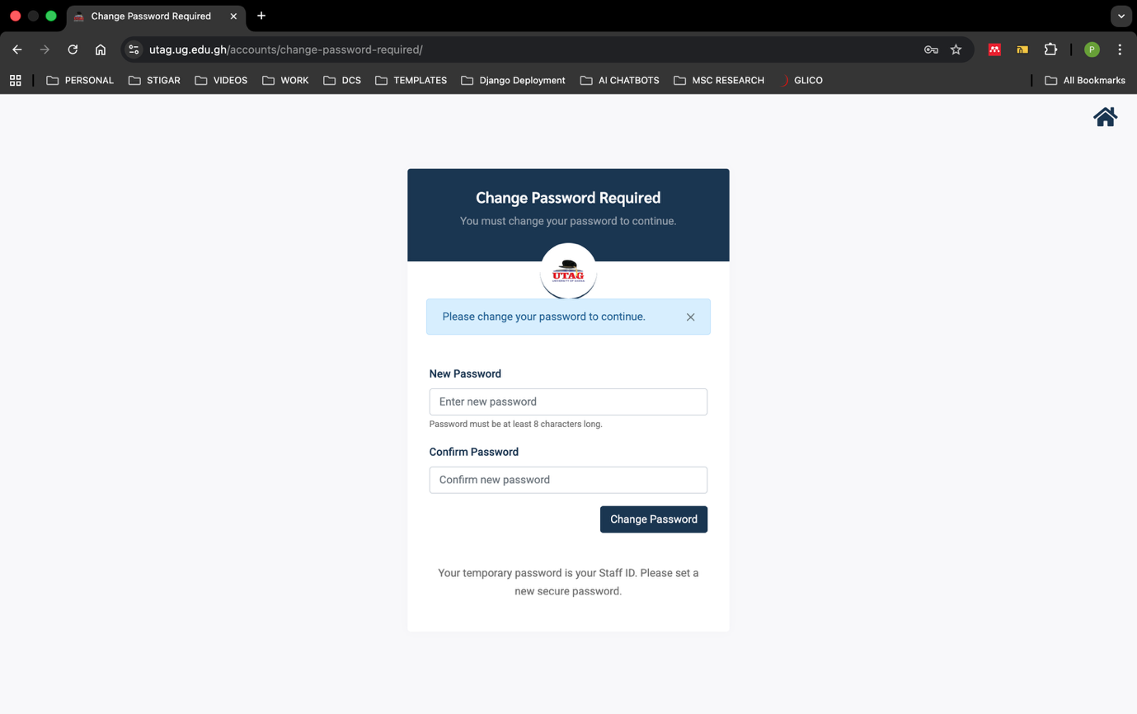
- On the forced password-change page:
  - New password: enter your chosen password.
  - Confirm password: re-enter it.
- Click Change Password.
Important: After you successfully change your password you will be required to sign in again using your staff email and the new password you just created. Capture a brief screenshot of the successful login
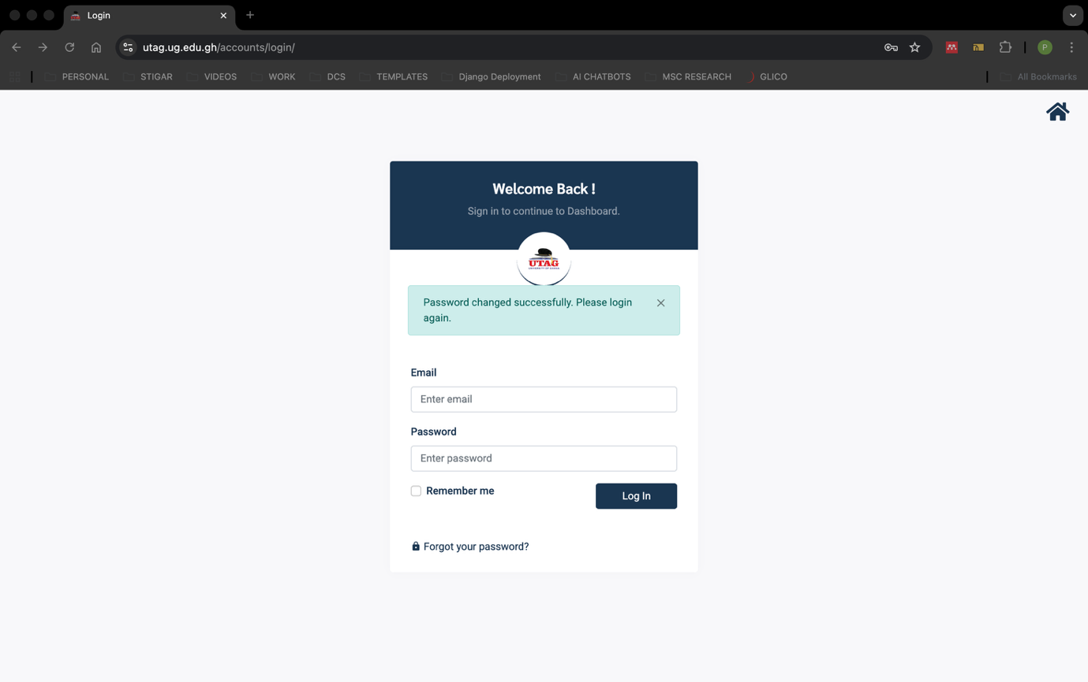

4) Profile setup
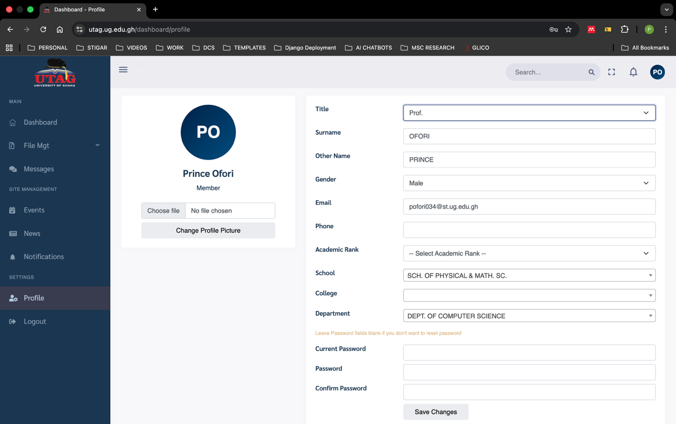
- After changing password you land on the Dashboard.
- To update your profile: open the left sidebar and click Profile
- Update your display name, phone number, upload a profile photo, and confirm your department/school.

5) Dashboard overview
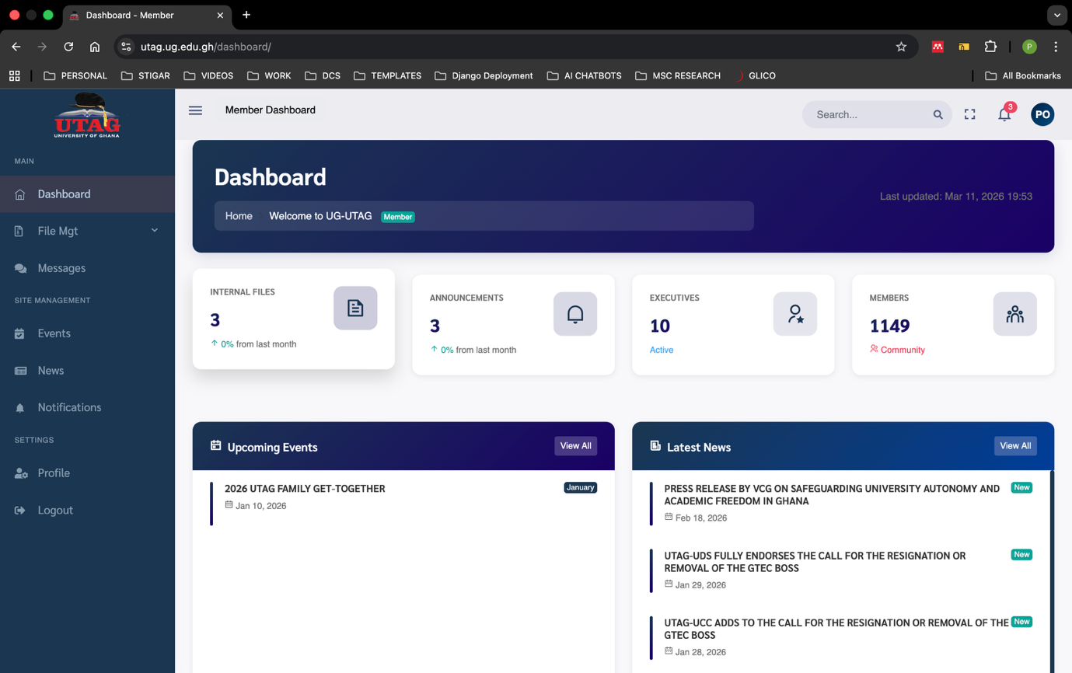
- Main regions:
  - Top bar: search, notifications, user menu.
  - Left sidebar: primary navigation. Use the exact sidebar labels shown in the app:
    - Dashboard
    - File Mgt (expandable)
      - Documents (under File Mgt)
    - Messages
    - SITE MANAGEMENT section:
      - Events
      - News
      - Notifications
    - SETTINGS section:
      - Profile
      - Logout

6) Common workflows
- Documents (File Mgt → Documents):
  - Action: Click File Mgt → expand and select Documents → browse or open documents.
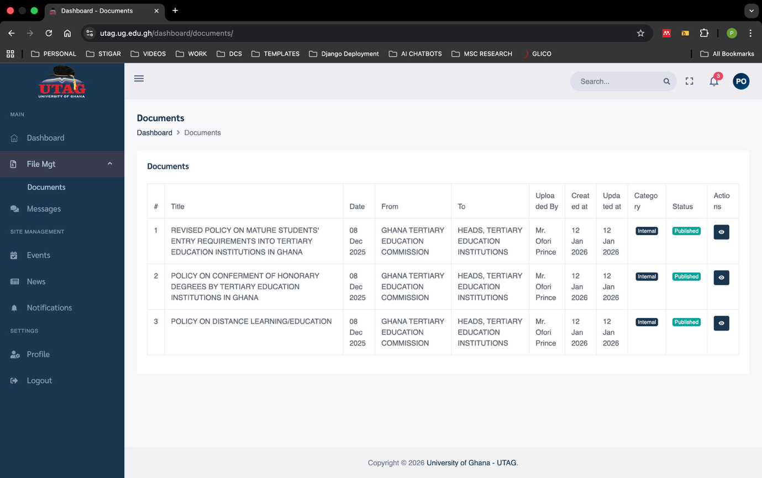
- Messages:
  - Action: Click Messages → open a conversation/thread → send and receive messages.
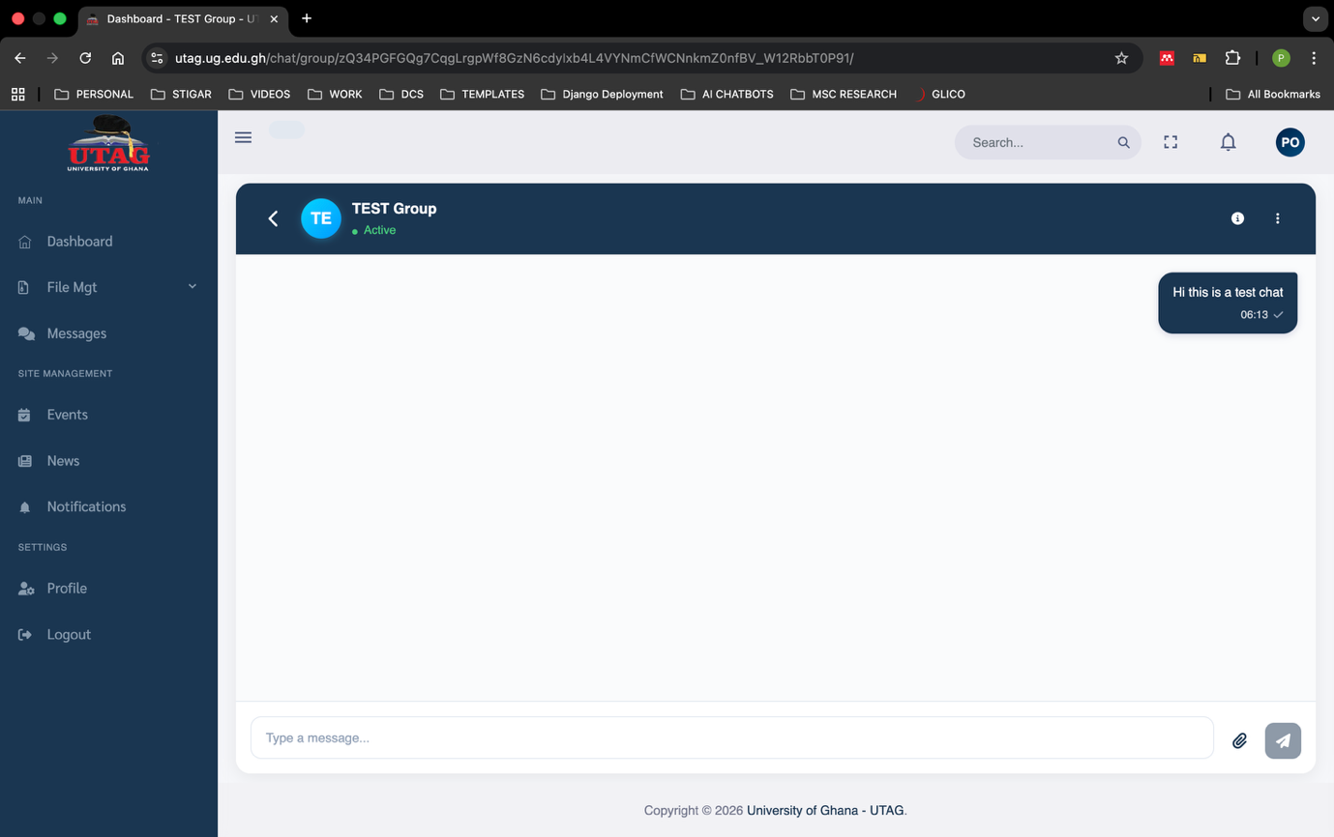
- Events:
  - Action: Click Events → browse list → click an item for details.
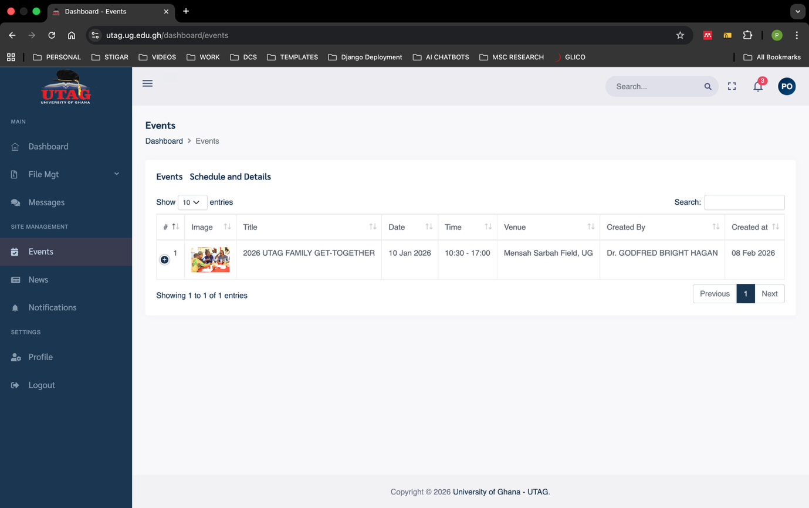
- News:
  - Action: Click News → read published news items.
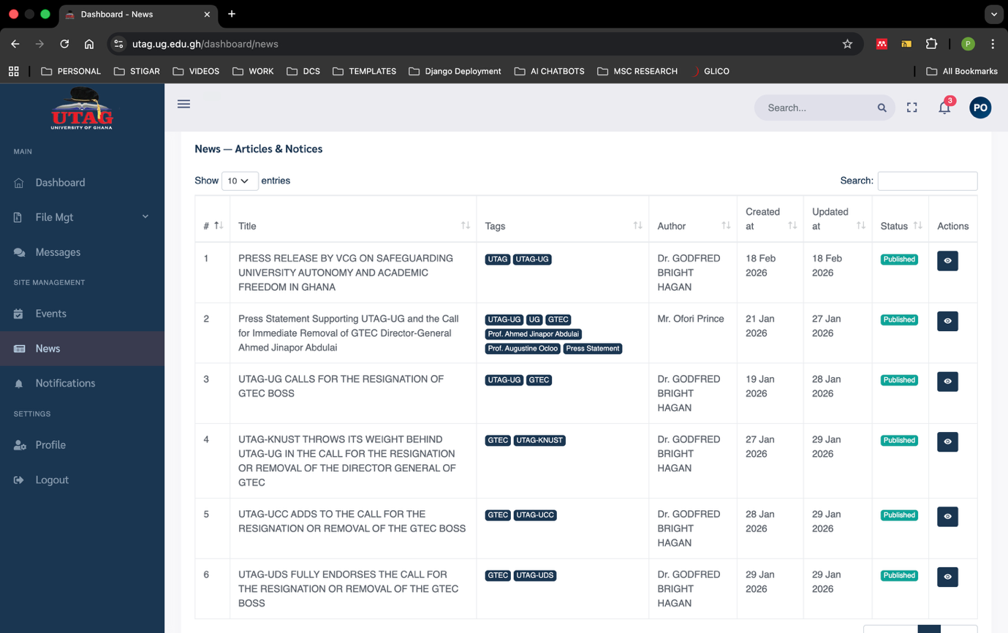
- Notifications:
  - Action: Click Notifications → view unread notifications and details.
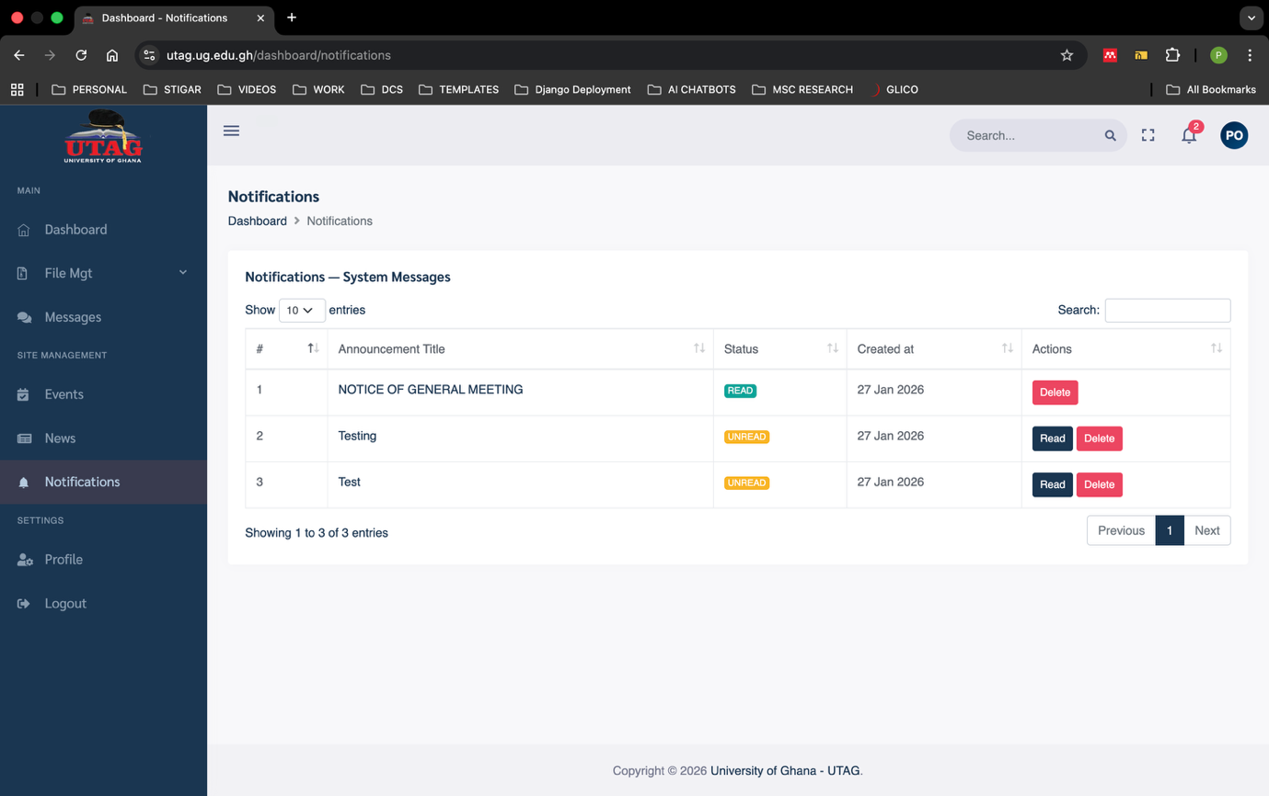

7) Troubleshooting snippets
- Cannot sign in:
  - Verify you used your staff email.
  - Confirm temporary password equals your Staff ID.
  - Try a different browser or clear cache; still failing → contact any of the executive members.
- Password change error:
  - Confirm both password fields match and meet complexity.
  - Copy the error and send to any of the executive members with a screenshot.

If You’re Unable to Log In to the Dashboard
Kindly share the following details:
- Staff Email
- Temporary Password used (Staff ID)
- Error message seen
- Screenshot of the issue
Submit the details above to the Executives for assistance and resolution.

